1. 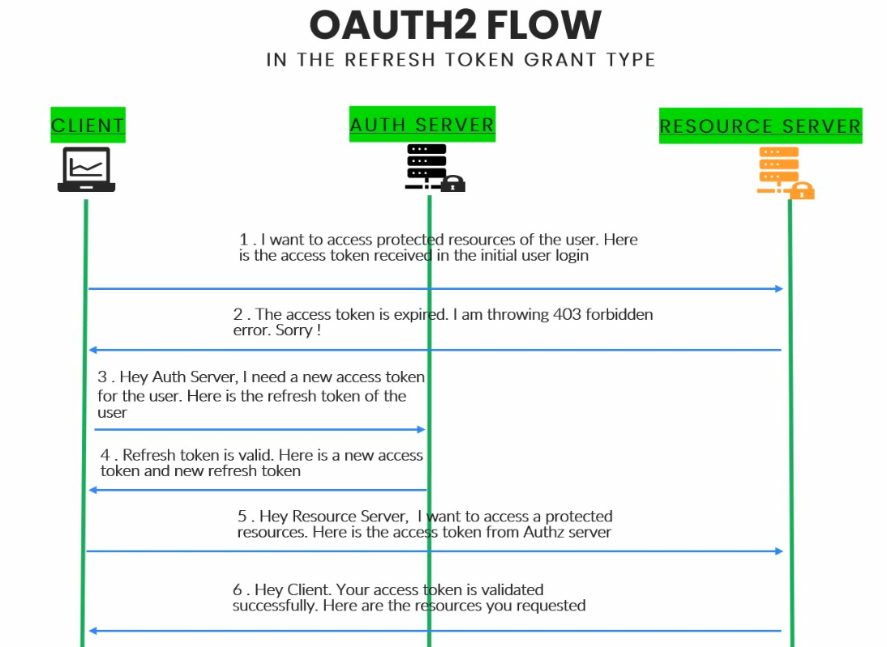
2. Think of a scenario where on Stackoverflow, your token gets expired and Stackoverflow again asks for your credentials when you visit that site, how annoying it is.
3. So better if Stackoverflow refreshes your token automatically when it gets expired.
4. **NOTE**: Resource owner is not involved in this flow.
5. 